Lab 2

Git and GitHub in VS code: Stage, commit, push, and pull command in Git

Lab objective

Lab instruction

1. Create a project folder and name it ‘lab2_git’.
2. Open Visual Studio code and open the project folder ‘lab2_git’
3. Before start the program, check if ‘git’ is already installed. To do so, we can go to the top menu and click on ‘Terminal’ tab. From the ‘Terminal’ list, click on the ‘New Terminal’ link to open VS code Terminal. In the Terminal, type ‘git –version’, if it shows a version number, it means that git is already installed in the computer:

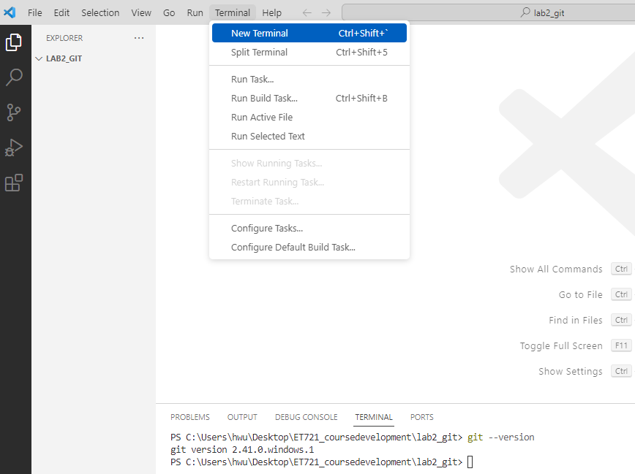

If it doesn’t show a version number, it means that git was not installed and you will need to install git.

1. In the project folder, click on the ‘source control’ icon, which is the third icon from the left column.
2. In the ‘source control’ has two options ‘initialize repository’ and ‘publish to GitHub’. For this lab, we are going to initialize the repository.
3. After it, it should the source control window the text field to type a message and the button to publish branch as shown below:

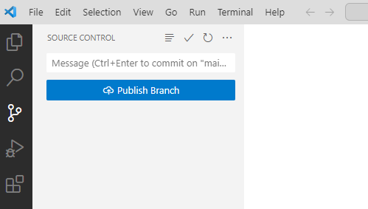

1. Once the repository is initialized, you should see a hidden holder named ‘git’ in the project folder:

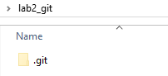

1. Create a new Python file named with your last name, for example, if the student’s last name is Smith, then we can save the file as ‘Smith.py’. In the Python file, we are going to add the following lines:

"""

Student's full name

Lab 2: Git and GitHub repository

"""

print("Welcome to Git commands")

1. Save the Python file and click in the ‘version control’ icon.
2. In the ‘version control’, we are going to commit the changes. For this, we type as a message ‘new Python file to test git commands’ in message text field.
3. After it, we are going to add the changes by clicking on the ‘+’ sign next to the file name. The file should be under ‘Changes’.
4. After clicking the ‘+’ sign, the Python file should be moved to ‘Staged Changes’ as shown below:

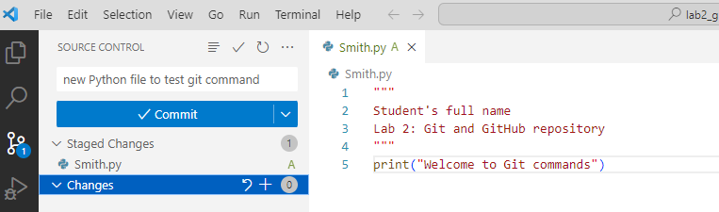

Click the ‘Commit’ button to save all changes.

1. If the repository is not configured yet, it will pop a window asking to configure the repository:

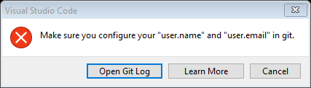

1. To configure the git repository, we go to the Terminal and type:

git config --global user.name "professorWu"

press ‘Enter’

1. Type:

git config --global user.email "students@email.com"

press ‘Enter’

1. After if, we publish it to the GitHub repository by clicking on the ‘Publish Branch’ link. It should pop-up a window asking if you want to sign in using GitHub:

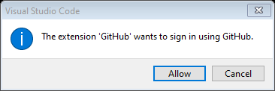

We click ‘Allow’ and it will take the user to the GitHub account:

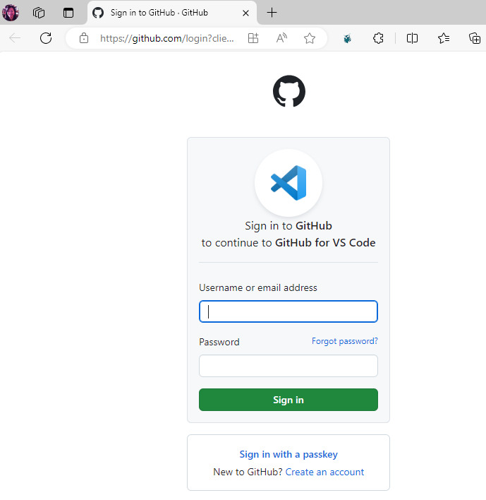

1. If you have a GitHub account, log in to your GitHub account, If you don’t have a GitHub account, click on ‘Create an account’
2. After it, in Visual Studio Code will ask if you want to publish the repository as private or public. For this lab, we are going to set the repository as ‘public’
3. Open your GitHub account and you should see the new repository created in your GitHub account as shown below:

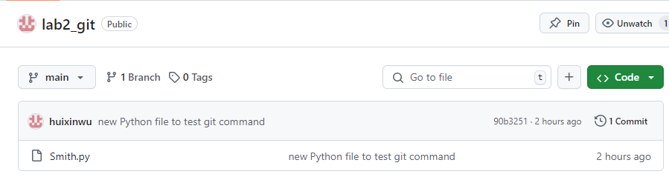

1. Back to Visual Studio Code, the following line before the print() command in your Python file:

username = input("Enter a username: ")

The complete Python file should have the following lines:

"""

Student's full name

Lab 2: Git and GitHub repository

"""

username = input("Enter a username: ")

print("Welcome to Git commands ", username)

1. After you made the changes to the Python file, in order to save your changes to your repository in GitHub, we must commit the changes. To do so, add the message ‘added username variable’, click on the ‘+’ sign to stage the changes, and press the ‘commit’ button.

The link ‘Sync Changes’ appears and if we want synchronous the changes to our repository in GitHub, we click on ‘Sync Changes’.

1. Go to your GitHub repository and click on the Python to open the file. You should see the Python file with the latest update as shown below:

